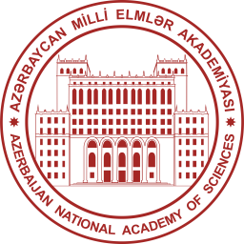

**Azerbaijan National Academy of Sciences**

**Council of Young Scientists and Specialists**

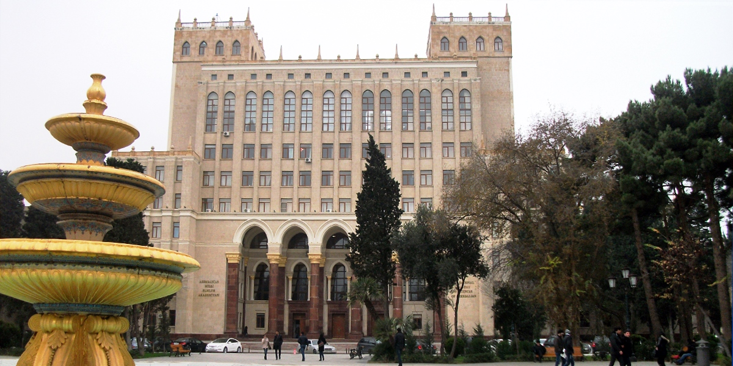

International Multidisciplinary Forum of

Young Scientists and Specialists

**“Academic science week – 2015”**

Dedicated to the 70th anniversary of

Azerbaijan National Academy of Sciences



**November 2-4, 2015**

**Baku, Azerbaijan**

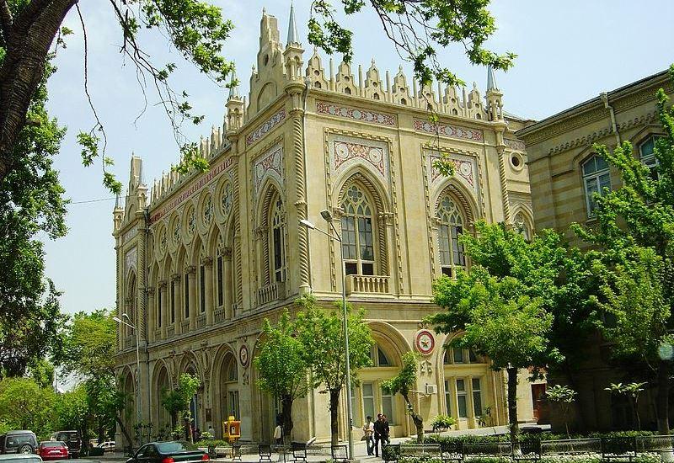

**About the Azerbaijan National Academy of Sciences**

Azerbaijan Academy of Sciences was established by the decision of Council of People's Commissars of the USSR on January 23, 1945. On March 31 of that year, at the General Meeting of the Academy M.Mirgasimov was elected the first President of the Academy

By the Decree of President Heydar Aliyev dated May 15, 2001, Azerbaijan Academy of Sciences has gained the status of “National Academy of Sciences”. This Decree proves the fundamental achievements of science in Azerbaijan, role of science in socio-economic, cultural and spiritual formation of Azerbaijan, and its prestige in social-political life of the country. By the Heydar Aliyev's Decree dated January 4, 2003, Azerbaijan National Academy of Sciences was charged the status of a public authority implementing scientific and technical policy of the state.

ANAS has 6 departments: Physical-Mathematical and Technical Sciences; Chemical Sciences; Earth Sciences; Biology and Medical; Humanitarian; Social Sciences; Agrarian Sciences. ANAS has 2 regional branches (Nakhchivan və Ganja), also 3 regional scientific centers (Shaki, Lankaran and Guba).

The fundamental and applied research, fulfilled in Azerbaijan National Academy of Sciences wich is the main scientific organizations of Azerbaijan, and its relevant organizations have contributed to the various stages of development of the oil and chemical industry, agriculture, culture and other fields, and especially in the preparation of highly qualified scientific personnel in the former Soviet Union and independent Azerbaijan. ANAS is a member of many prestigious international scientific organizations and its employees cooperate with leading scientific and educational institutions under the program of conducting research, training and information exchange with CIS countries as well as USA, Japan, Israel, Switzerland, England, Germany, Pakistan, Turkey, Iran and other countries. The current President of Azerbaijan National Academy of Sciences is Akif Alizadeh.

This year are planned the implementation of a series of scientific and public events in connection with the 70th anniversary of Azerbaijan National Academy of Sciences. "Academic science week - 2015" International Multidisciplinary Forum which is also dedicated to the 70th anniversary of Azerbaijan National Academy of Sciences includes important issues such as constructive dialogue between young and old scientists, bringing together government and business representatives to ensure the issue of information and communication platform.

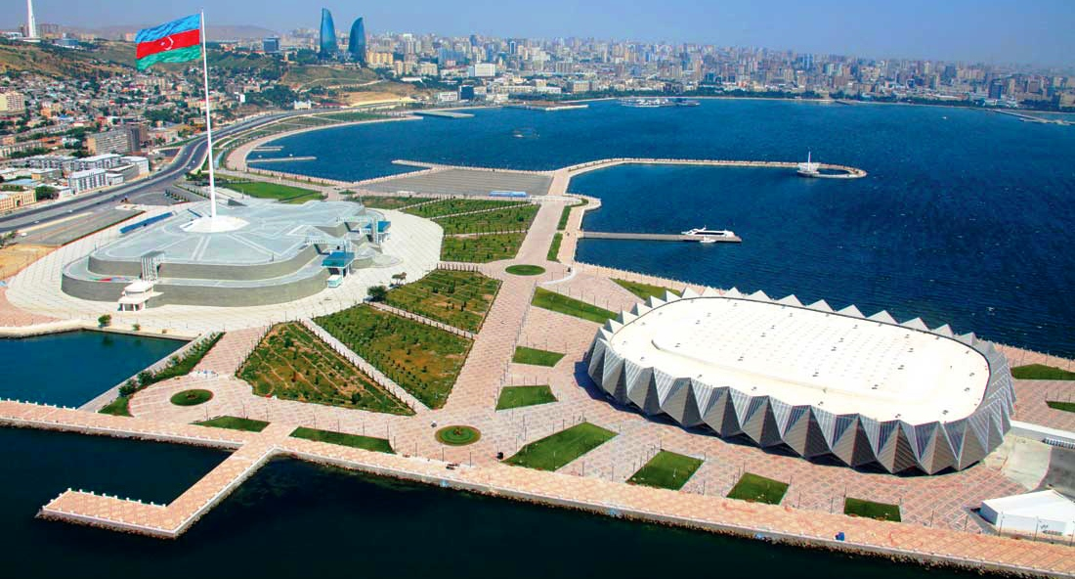

Dear colleagues!

Azerbaijan National Academy of Sciences is holding International Multidisciplinary Forum of Young Scientists and Specialists "Academic science week - 2015", will be holding on November 2-4, 2015.

The event dedicated to the 70th anniversary of ANAS and aims to bring together research and educational institutions of the country, relevant ministries, scientific funds, entrepreneurs and media representatives.

It is planned to organize a conference with the purpose of organize international debates on multidisciplinary scientific directions which is very actual nowadays and provide active participation of young researchers in these debates.

We invite young scientists and specialists of academic institutions, as well as other relevant research and industrial organizations to take part in the International Multidisciplinary Forum of Young Scientists and Specialists on behalf of the Scientific Organizing Committee.

We forward to seeing you soon in Baku.....

Chairman of Scientific Organizing Committee,

Academician **Fakhraddin Gadirov**

**Scientific Organizing Committee**

**F.A.Gadirov**  Academician, Academician-secretary of Earth Sciences Department (ANAS),

Chairman of Scientific Organizing Committee

**D.B.Taghiyev** Academician, Academician-secretary of Chemical Sciences Department (ANAS),

Co-chairman of Scientific Organizing Committee

**F.T.Salmanov** PhD in Physics, Associate Professor, Chairman of Council of Young Scientists and

Specialists of ANAS, Deputy of Scientific Organizing Committee

**G.R.Babayev** PhD in Earth Sciences, Associate Professor, Head of the [International  Relations Office](http://www.science.gov.az/en/presidium/sections9.htm)

(ANAS), member of Scientific Organizing Committee

**O.R.Abbasov**   PhD in Earth Sciences, Chairman of Council of Young Scientists and Specialists of

İnstitute of Geology and Geophysics (ANAS), member of Scientific Organizing Committee

**A.R.Sujayev** PhD in Chemistry, Chairman of Council of Young Scientists and Specialists of İnstitute

of  [Chemistry of Additives (ANAS)](http://science.gov.az/institutes/12), member of Scientific Organizing Committee

**F.M.Mammadov** PhD in Chemistry, Associate Professor, Chairman of Council of Young Scientists and

Specialists of İnstitute of [Catalysis and Inorganic Chemistry (ANAS)](http://science.gov.az/institutes/11), member of

Scientific Organizing Committee

**E.A.Babaeva** PhD in Phylology, Associate Professor, Chairman of Council Young Scientists and

Specialists of İnstitute of Literature (ANAS), member of Scientific Organizing Committee

**A.E.Jabrailova** Member ofCouncil of Young Scientists and Specialists of İnstitute of Geology and

Geophysics (ANAS), Scientific-secretary of Scientific Organizing Committee



**Official languages of the Forum**

Azerbaijani and English

**Scientific programme**

* + The forum includes interactive and plenary debates

* + Discussion on panels

**The forum venue**

The main building of Azerbaijan National Academy of Sciences

and the Academy Town

**Deadlines**

**July 15, 2015** Starting of registration

**September 15, 2015** Deadline for registration of participants

**September 30, 2015** [Deadline for submission of abstracts](http://home.iitk.ac.in/~ramesh/deadline.html)

**October 20, 2015** Deadline for booking of hotel (only for foreigners)

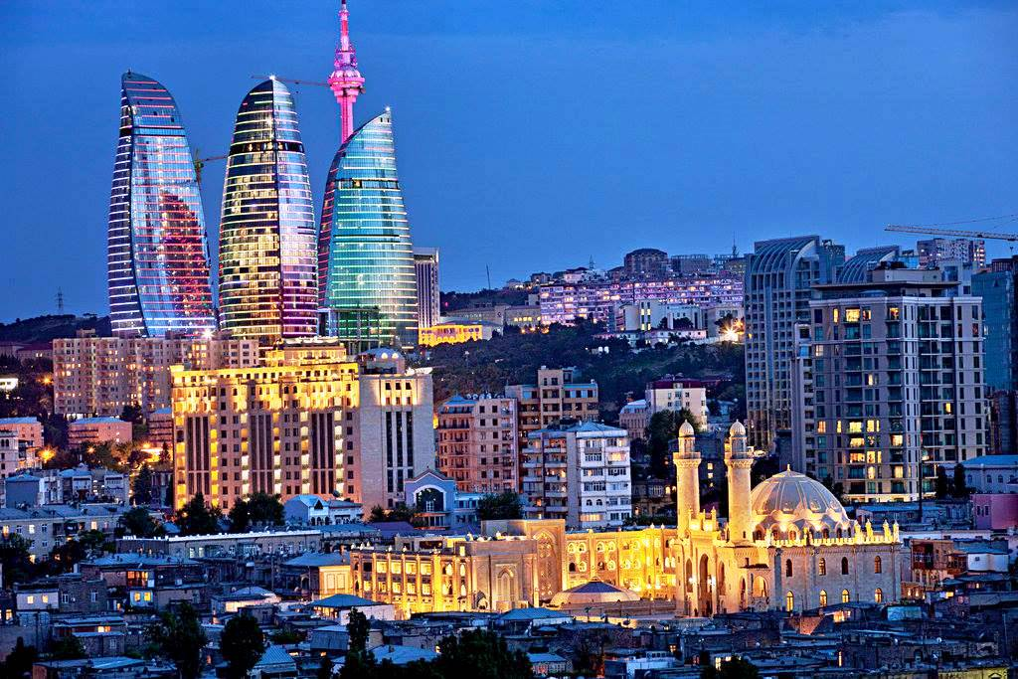

**Interactive discussion topics**

* Academic startups - what should be considered a success?
* The role of funds in science development
* Innovative ideas and perspectives

**Topics of the conference panels**

* Multidisciplinary approach in science
* New achievements and prospects of [Information & Communication Technologies](https://www.google.az/url?sa=t&rct=j&q=&esrc=s&source=web&cd=8&cad=rja&uact=8&ved=0CEMQFjAH&url=http%3A%2F%2Fwww.worldbank.org%2Fen%2Ftopic%2Fict%2Foverview&ei=74idVfyaG4mlsAGryoOADw&usg=AFQjCNFiDSjH_KhLs3FGg36UexTTAUegEw&bvm=bv.96952980,d.bGg)
* From Theory to Practice
* [Life and environmental](https://www.google.az/url?sa=t&rct=j&q=&esrc=s&source=web&cd=11&cad=rja&uact=8&ved=0CGEQFjAK&url=http%3A%2F%2Fwww.tsukuba.ac.jp%2Fenglish%2Forganization%2Fgraduate%2F0305.html&ei=4oudVdKVL8yxsAG2taTYDg&usg=AFQjCNHbiD7RGyRDop-TcM2f85OnjOunMQ) safety

**Cultural events**

* “Welcome party”
* City tour (Maiden Tower, Shirvanshahs Palace, the National Museum of Azerbaijan Literature named after Nizami Ganjavi, Flag Square etc).
* Mud volcano tour
* Gobustan National Historical-Artistic Reserve
* “Gala party”

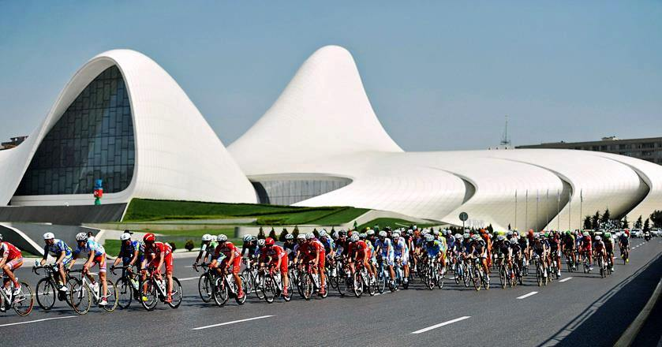

**Age limit for participants**

Young scientists and specialists under the age of 40

**Compensate of expenses**

Hospitality, intended to set sail and conference-related expenses (hotel, food, etc.) will be paid by the Organizing Committee.

**Visa appeals**

Visa is required for the arrival of some foreign citizens to Azerbaijan. In this connection, it is recommended to contact the local Azerbaijani embassies. For more details, please contact the following: [www.mfa.gov.az](http://www.mfa.gov.az).

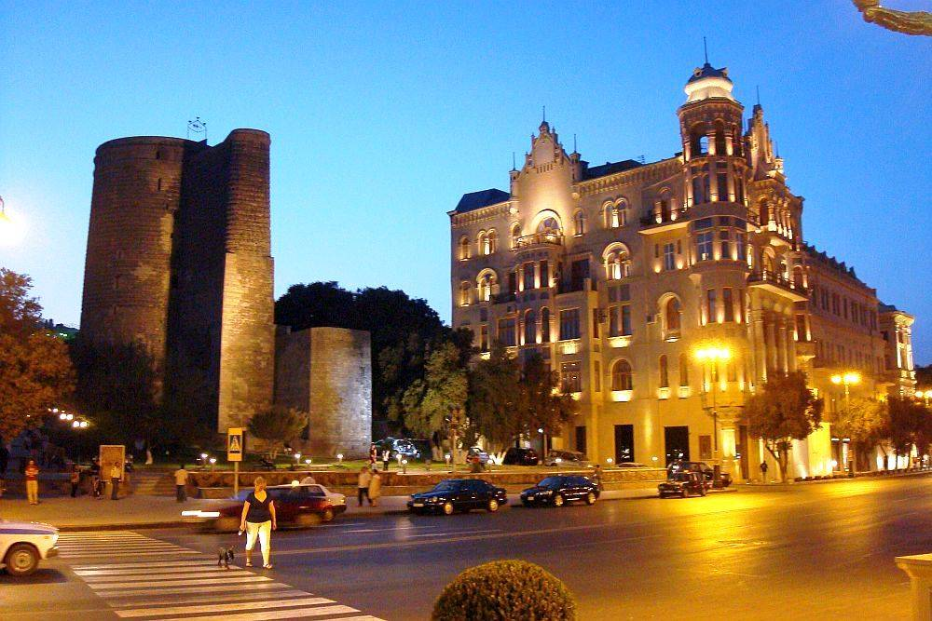

**Guidelines for abstrac submission**

The body of the abstract is accepted in the electronic format typed in MS Word. Font – Times New Roman (12pts), with single line spacing. Paper format is А4, margins are 2.5 cm. The thesis length should not exceed 2 pages, including one figure and one table;

The title of the thesis – capital letters, bold (11pts), aligned centrally, without indent. Next line should contain family name and initials of the authors, italic, aligned centrally. If the authors are from different organizations, indicate *;

Next line with * should contain the full name of the organization, city, country and email address of the presenter. Fonts are 11 pts, italic, aligned central.

The figure should be inserted in the text as JPEG.

A summary in English must be submitted in abstract that will be presented in the Azerbaijani language.

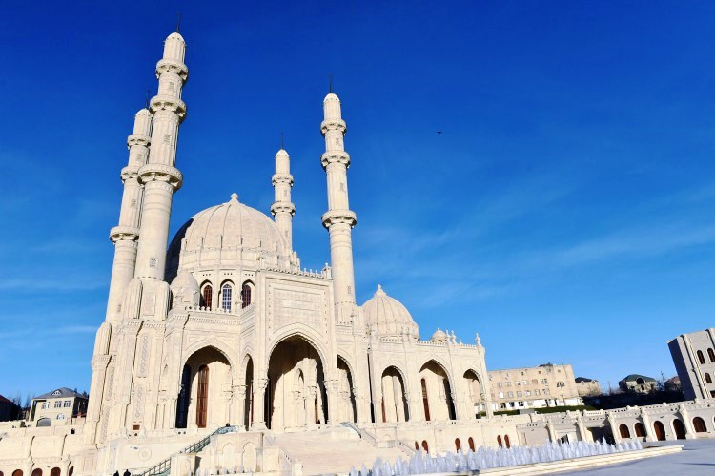

**Participant application form**

**S.F.N.:**

**Country/city:**

**Affiliation/education establishment:**

**Position:**

**Scientific degree:**

**Title of abstract:**

**Mark the appropriate panel for presentation:**

**Address:**

**E-mail:**

**Tel:**

**Official letter**

**Official letter for conference:**

**required  not required** 

**Contacts**

***Address:*** *Azerbaijan, Baku, H. Javid, 115*

***E-mail:***[*forum.baku.2015@gmail.com*](mailto:forum.baku.2015@gmail.com)

***Tel:*** *+ 99412 539 25 79*

***Mobile: +*** *99450 334 69 39*

[***www.gencalimler.az***](http://www.gencalimler.az)